25th August 2020

Dear Families

**September re-opening: updates for families**

Our detailed planning has continued over the summer holidays to ensure that we will be ready to welcome back all students to HT, full-time from September.  We have made many changes to how school will operate, but at the heart of our school community will still be a focus on strong relationships and excellent teaching to ensure the best possible support for our students on their return to school.

We have ensured that all government advice for schools in England is fully followed, and we will keep our procedures under review should that guidance change.  To provide clear information about our re-opening arrangements, and our ‘new normal’ there are some slides linked to this letter, which are also on the school’s website.  They can be found here:

Our full re-opening Risk Management Plan can also be viewed on the school’s website here: <https://haileyburyturnford.com/app/uploads/2020/08/Haileybury-Turnford-September-2020-Risk-Management-Plan-v1.pdf>

I recognise that there will be a range of feelings and concerns about the re-opening of schools.  This is only natural.  We will do all we can to ensure school is as safe as possible for all students and staff.  Of course, it is not risk free, but we will do all we can to reduce risk and create an inherently safer school environment.  The majority of students have not been in school for over 5 months, and it is essential that we now do all we can to ensure students can learn confidently and effectively in school again.  The recently published statement from the Chief Medical Officers and Deputy Chief Medical Officers of England, Scotland, Northern Ireland and Wales on the current evidence of risks and benefits to health from schools re-opening can be read here: <https://www.gov.uk/government/news/statement-from-the-uk-chief-medical-officers-on-schools-and-childcare-reopening>

I was also delighted that Haileybury Turnford has been able to support Hertfordshire County Council’s ‘Play Your Part’ campaign – their schools re-opening video for families can be viewed here: <https://www.youtube.com/watch?v=8jaM83GV7QI>

There will be further information for each year group before school re-opens.  Key senior and pastoral staff are listed below.

|  |  |  |
| --- | --- | --- |
| **Year Group** | **Senior staff lead** | **Year Achievement Coordinator** |
| Year 7 | Miss Newman | Miss Allingham |
| Year 8 | Mr Walsh | Mr Barrett |
| Year 9 | Mr Megaw | Miss Kaposi |
| Year 10 | Mr Macaulay | Ms Johnson |
| Year 11 | Mr Macaulay | Mr Macaulay |
| Year 12 | Mrs Shivalkar | Mr Lindquist |
| Year 13 | Mrs Shivalkar | Miss Goody |

For students with Special Educational Needs and Disabilities, Mrs Mitchell, our Flex/SEND Coordinator will coordinate specific support.

We look forward to welcoming our students back to school from next Friday.  The phased start of term arrangements for each year group can be seen below:

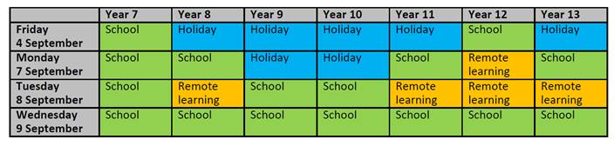

Stay safe.

Yours faithfully



Robin Newman

Principal