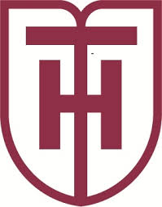
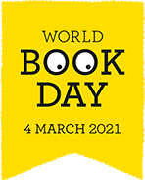
OD BOOK DAY
Changing lives throug h a love of books and shared reading.

HT Library World Book Day Competition 2021
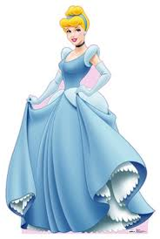
“Goodies & Baddies” is this year’s theme. You need to pair up characters from well known stories. Fill in the 10 Baddies and send your answers to me by email saundersa@haileyburyturnford.com Deadline: 2pm Friday 5th March. Top three entries drawn with most correct answers will receive a prize. Good Luck!!
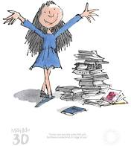
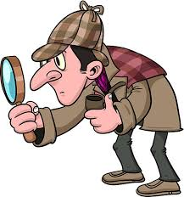

“Goodies” “Baddies”
- Peter Pan ……………………………………………
- Harry Potter ……………………………………………
- Sherlock Holmes ……………………………………………
- Matilda ……………………………………………
- Sleeping Beauty ……………………………………………
- Hercules …………………………………………….
- Robin Hood …………………………………………….
- Alice in Wonderland …………………………………………….
- Cinderella …………………………………………….
10.Oliver Twist ……………………………………………

